**DESIGN YOUR UI TO DISPAY THE TEMP**

**ERATURE,**

**HUMIDI**

**TY**

Team

Id

PNT2022TMID08806

Title

Hazardous Area Monitoring

for

Industrial

Plant

using

IoT

**In MIT**

**App**

**Inventor**

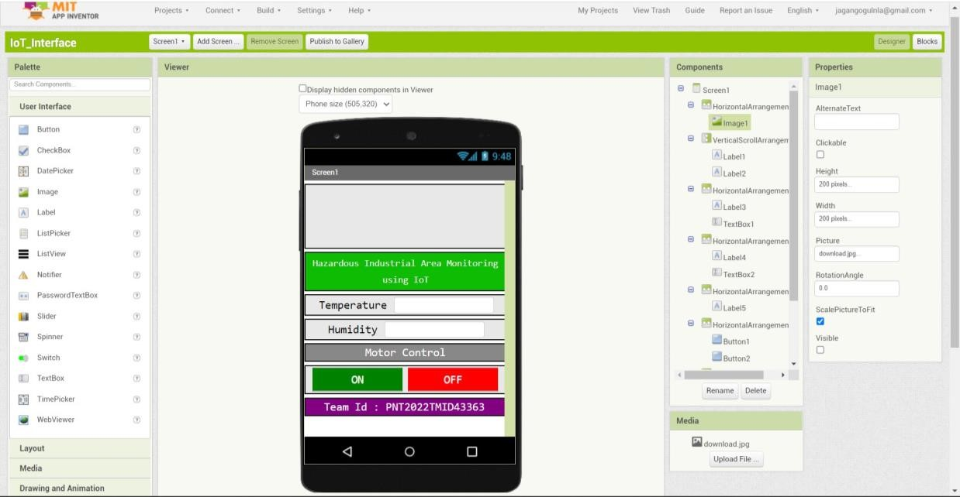

**In**

**Mobile**

**Phone**

